Title Goes Here

Seminar / Bachelor / Master Thesis

Submitted to

Chair of Smart Services
Prof. Dr. Martin Adam
University of Göttingen

In
Month Year

By
Firstname Lastname

Student ID:
000000

Academic Program:
B.Sc. Business Information Systems

Supervisor1:
Supervisor2:

Declaration

I herewith formally declare that I, first name last name, have written the submitted manuscript independently. I did not use any outside support except for the quoted literature and other sources mentioned in the paper. I clearly marked and separately listed all of the literature and all of the other sources which I employed when producing this academic work, either literally or in content. This submission has not been handed in or published before in the same or similar form. I give my consent to have this thesis checked by plagiarism software.
I am aware, that in case of an attempt at deception based on plagiarism, the submission would be graded with 5.0.

Göttingen, June 26, 2024

Last Name:
First Name:
Student ID:
Signature: ________________
Abstract
Here goes your abstract. This is exemplary text in “Text” style. A typical abstract has 150-250 words. This template should serve as a template for students, supporting them in writing theses at the Chair of Smart Services. The language of the theses is English (decide on US or GB spelling and use it consistently!). Please note that all text, figures, tables, appendices and references are placeholders!
Table of Contents
List of Abbreviations iv
List of Figures v
List of Tables vi
1 Basics for Bachelor/Master Thesis 1
2 Formal Requirements 1
2.1 Text 1
2.2 Headers and Footnotes 1
2.2.1 Headers 2
2.2.2 Footnotes 2
2.3 Chapters, Subchapters, Paragraphs and Page Margins 3
2.3.1 Sublevels 3
2.3.2 Paragraphs and Page Margins 3
3 Structure and Length 3
3.1 Introduction 4
3.2 Basics 5
3.3 Main Section 5
3.4 Conclusion 5
3.5 References 6
3.6 Appendix 6
4 References in Text 6
4.1 Indirect Citation in Text 6
4.2 Direct Citation in Text 6
4.2.1 Modified Direct Citation in Text 7
4.2.2 Another modified Direct Citation in Text 7
4.3 Managing References 7
4.4 List of References 8
4.5 Indication of Co-authored Parts 9
5 Figures and Tables 9
5.1 Figure Style 10
5.2 Another Figure 11
5.3 Table Style 11
5.4 Another Table 12
References 13
Appendix vi

List of Abbreviations
<Example, ordered alphabetically> (remove this note!)
CIO Chief Information Officer
XML Extensible Markup Language

Further information:
All abbreviations used in the work (also from diagrams and overviews) and their meaning in alphabetical order, even if they have already been explained in the text, must be listed in the list of abbreviations. Acceptable abbreviations are those commonly used in business as well as common abbreviations for journals, newspapers, institutions and organisations.
Abbreviations that are not commonly used are not permitted, as they disturb the reading flow (e.g., AS for application system). Use abbreviations sparsely; some are common and should not be included in the list of abbreviations (e.g., etc., viz., …)

List of Figures

Figure 1. Illustrative Studies in the Green IS Literature Focusing on Smart Meters, Goal-Setting, and Social Comparison [source: Wendt et al. 2024] 10
Figure 2. Research Model [source: Adam et al. 2022] 11

List of Tables

Table 1. Differences Between Bachelor and Master Thesis 1
Table 2. Zotero Links 8
Table 3. Descriptive Statistics of Demographics, Mediator, and Controls [source: Adam et al. 2021] 11
Table 4. Experimental Design [source: Berger et al. 2021] 12

- Basics for Bachelor/Master Thesis
Theses (bachelor and master) differ in terms of editing time, lengthand whether the results must be shown in a presentation. Table 1 shows an overview of these differences.
Table 1. Differences Between Bachelor and Master Thesis
 | Editing time | Length | Presentation of the thesis | Second examiner
Bachelor thesis | 12 weeks | about 30 pages | No | Second examiner is a research associate, if the Faculty of Economics Sciences is responsible. Otherwise, a second examiner has to be arranged.
Master thesis | 20 weeks | about 60 pages | 30-minute presentation of the master thesis | Second examiner is a research associate, if the Faculty of Economics Sciences is responsible. Otherwise, a second examiner has to be arranged.

- Formal Requirements
In this section, the formal requirements for bachelor and master thesis as well as for seminar papers will be explained.

  - Text
- The body of your work can be formatted in Arial, Calibri, or Times New Roman. The font size must be 12 pt. (Arial 11 pt.)
- Please use a line-spacing of 1.5 lines.
- Please format the text body as a fully justified text.

  - Headers and Footnotes
This section describes the formal requirements for headings and footnotes.
    - Headers
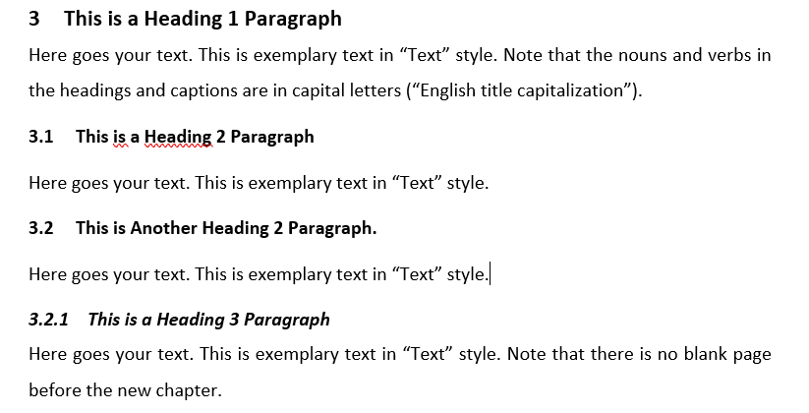
- Headers on the first level can be formatted in 14 pt. and bold, and all sub-levels must be formatted in the size of the text and bold, meaning 12pt. or 11pt. (see this document as an example).
- Avoid two or more subsequent headers without a text interposed.
- A new subchapter should only be added if there are at least two subsections (e.g., don’t add chapter 2.1 if there is no chapter 2.2)
- It is advisable to inform the reader about the structure of the following sections (see above).

    - Footnotes
- If a reference is important, then it belongs in the text. If the reference is not necessary, you should consider whether the reference can be omitted.
- You can use footnotes if certain sections need further explanations, but they could disturb the reading flow.
- Footnotes should be written as normal sentences. They begin with a capital letter and end with a period.
- They should be numbered consecutively in Arabic numerals.
- Footnotes should be formatted in font size 10 pt.
- Concerning footnotes and punctuation: If a footnote relates to the whole sentence, it should be placed behind the punctuation mark, if the footnote relates to just one word, it should be placed behind the word it relates to and before the punctuation mark.

  - Chapters, Subchapters, Paragraphs and Page Margins
- The thesis should be well-founded and structured. A new subchapter should only be added if there are at least two subsections.
- The subject of the paper must not be completely processed in just one chapter.
- If different aspects are covered in one chapter or subsection, use paragraphs to structure the text.
- A good structure normally consists of four to seven chapters (plus subsections/subchapters).

    - Sublevels
Do not use more than four subchapters (sublevels). Create only a new sublevel if it is necessary.

    - Paragraphs and Page Margins
- Use a line spacing of 1.5. Paragraphs should be reasonably placed and in relation to their content.
- The page margins should be 2.5 cm for all margins.
- The text should be fully justified.

- Structure and Length
A thesis or paper normally consists of the following parts:
- Cover page
- Table of Contents
- List of Abbreviations (if necessary)
- List of Figures (if necessary)
- List of Symbols (if necessary)
- Content
- References
- Other sources (if necessary)
- Appendix (if necessary)
The text of the thesis/paper follows the list of figures/tables. It should be written in proper English orthography (British or American). In general, it consists of the presentation of the problem, a section of definitions, the actual processing of the problem (and possibly a solution), and a summary of the main findings. A possible, typical structure could be:
- Introduction
- Groundwork/literature review
- Methods/analysis
- Findings/evaluation
- Conclusion
The length of a seminar paper is indicated in the description of said seminar or must be individually set with the supervisor.

  - Introduction
- In the first section you should always present the given issue of the paper/thesis. Further comments regarding the relevance of the issue are also applicable.
- You should specify some aspects of the problem as well as central issues that have to be solved in the paper.
- The following should be stated in the introduction: a short overview of the procedure, how, and in which sequence the issues are going to be covered.
- The following structure can be used for the introduction (maximum length of up to 3 pages, depending on the overall length of the paper):
  - Introduction of the topic
  - Formulation of the issue
  - Definition of the subject (including subjects that belong to the topic, but are not covered)
  - Structure of the paper/thesis (reasons and motivation for the chosen structure)

  - Basics
- In the second part, central terms and concepts need to be defined and classified.
- It is not a matter of looking for definitions from lexicons, but of using problem-oriented definitions.
- Often, some terms can be defined differently. So, a discussion of different approaches can be useful, before you choose a binding definition for the paper/thesis.
- A short literature review is useful especially for practical papers/theses (e.g., according to Webster and Watson). The reader should be informed of the quantity and type of research papers published, related to the given issue.

  - Main Section
- In the main section of the paper/ thesis (which should not be named “Main Section” obviously), the actual issue or problem should be dealt with.
- In doing so, a theoretical model can be pictured, or theory-driven hypotheses can be developed, which are then examined empirically in a subsequent analysis.
- In this part, it is essential to not just use and collect textbook knowledge but handle the issue in a reflective and goal-orientated manner.
- For a thesis: if some parts of the thesis are co-authored by another student (e.g., a survey) this needs to be clarified.

  - Conclusion
- The solution of the issues and problems dealt with should be presented briefly and concisely.
- In addition, you can give a further overview of issues that should be covered in future research.
- A critical reflection of the author’s work is always reasonable at this point.

  - References
- A bibliography must be attached to the work.
- The bibliography or list of references lists all publications cited in the paper/thesis, including those in tables or figures.
- Literature that was read but not cited does not belong in the list of references.

  - Appendix
You can put figures and diagrams in the appendix, which provide additional information. An appendix is not a necessary part of a paper/thesis, but rather an optional element, if further explanations are essential. This part should not be extended needlessly.

- References in Text
This section provides examples for citing correctly in the text. Please in general use the citation style of the American Psychological Association (APA), Seventh Edition.

  - Indirect Citation in Text
Syntax
Citation text (Author(s), Year)
Example
A signal may also contain information about potential requirements that essentially relate to the costs (e.g., required financial investment that a recipient must incur), which is in line with signaling theory (Adam et al., 2023).

  - Direct Citation in Text
Syntax
“Direct citation text” (Author(s), Year, Page(s))
Example
“This finding is further supported by the fact that social presence mediates the effect of ADCs on user compliance in our study.” (Adam et al., 2020, p. 437).

    - Modified Direct Citation in Text
Use [...] to omit parts of the cited text that are not crucial for its meaning:
“However, if decision makers’ expectations of an algorithmic advisor are overly high […], this reaction may lead to an irrational discounting of algorithmic advice.” (Berger et al., 2020, p. 65)

    - Another modified Direct Citation in Text
Add words in square brackets to achieve seamless transitions between your own ideas and the cited text:
Wendt et al. (2022, p. 6) present the social comparison theory in “which […] [they] theorise about residents' perception of their relative performance at the time of goal-setting”.

  - Managing References
Use Zotero! (or a similar tool) (see Table 2)
[zoh-TAIR-oh] is a free, easy-to-use tool to help you collect, organize, cite, and share your sources
Download Zotero citation style on our website https://www.uni-goettingen.de/de/templates/609290.html
Zotero can be integrated in Microsoft Word

Table 2. Zotero Links
Topic | Link
Quick Start Guide | https://www.zotero.org/support/quick_start_guide
Complete Beginner Guide (Video) | https://www.youtube.com/watch?v=JG7Uq_JFDzE
Citations and Bibliography in Word (Video) | https://youtu.be/JG7Uq_JFDzE?t=512
Set Zotero to English language | http://forums.zotero.org/discussion/4004/?Focus=17166#Comment_17166
Although it is very convenient, and everything is done for you: Visually check all references before handing in:
- Your Zotero database may be incomplete
- Citation style might not work for all types of references (e.g., magazines)

  - List of References
Basic remarks
- List of references is sorted alphabetically.
- “Et al.” is used in text citations if the cited object has more than two authors; in the bibliography all authors must be listed.
- For authors, last names are given first.
- See References section at the end of the document.
Best practices
- Use Zotero for managing your bibliography and citations
- Be aware that references downloaded from the web may not be correct a priori
- Perform regular bibliography checks

  - Indication of Co-authored Parts
Specifically, in thesis projects, it can be necessary to co-author parts of the text with other students, such as in the creation of a survey. This should be indicated in the certification, including a specification which parts are co-authored.
If whole passages of the text are identical, this needs to be also indicated in the header of the respective chapter. It is sufficient to list the names of all authors in squared brackets.
In seminar papers (especially group projects) these indications (in both the header and the certification) are not necessary, as a joint handling of the paper is generally assumed.

- Figures and Tables
- In figures and tables, you can summarize the pictured facts, illustrate certain matters, or highlight statements.
- Figures and tables support your argumentation but cannot replace your explanations. So further comments are necessary.
- If figures or tables include necessary information, put them in the text. If they provide only additional information, they belong in the appendix.
- Figures, tables, etc. must be numbered and labelled continuously (Calibri, font size 11 pt.), For example, Figure 1. Illustrative Studies in the Green IS Literature Focusing on Smart Meters, Goal-Setting, and Social Comparison (the exact format according to MISQ-style can be seen in the example below)
- If you refer to a figure/table in the text, for example “As seen in Figure 1, the effect of…”, the word “Figure” has the same notation as in the label (with a capital first letter).
- Figures and tables taken from other sources need to be cited correctly. The label must include the source of the figure or table, for example Figure 1: Illustrative Studies in the Green IS Literature Focusing on Smart Meters, Goal-Setting, and Social Comparison [source: Wendt et al. 2024].
- If you created the figure or table, just write “own research”.
- If figures from different sources are processed, recomposed and/or made comparable by rearrangement, so that it is no longer possible to identify the source of each individual figure, all sources must be indicated at the beginning of the section. A footnote should indicate the nature of the processing.

  - Figure Style
This is exemplary text with cross reference (see Figure 1) to show correct figure style. The caption is in “Figure/Table Caption” style and integrated, but below the figure.
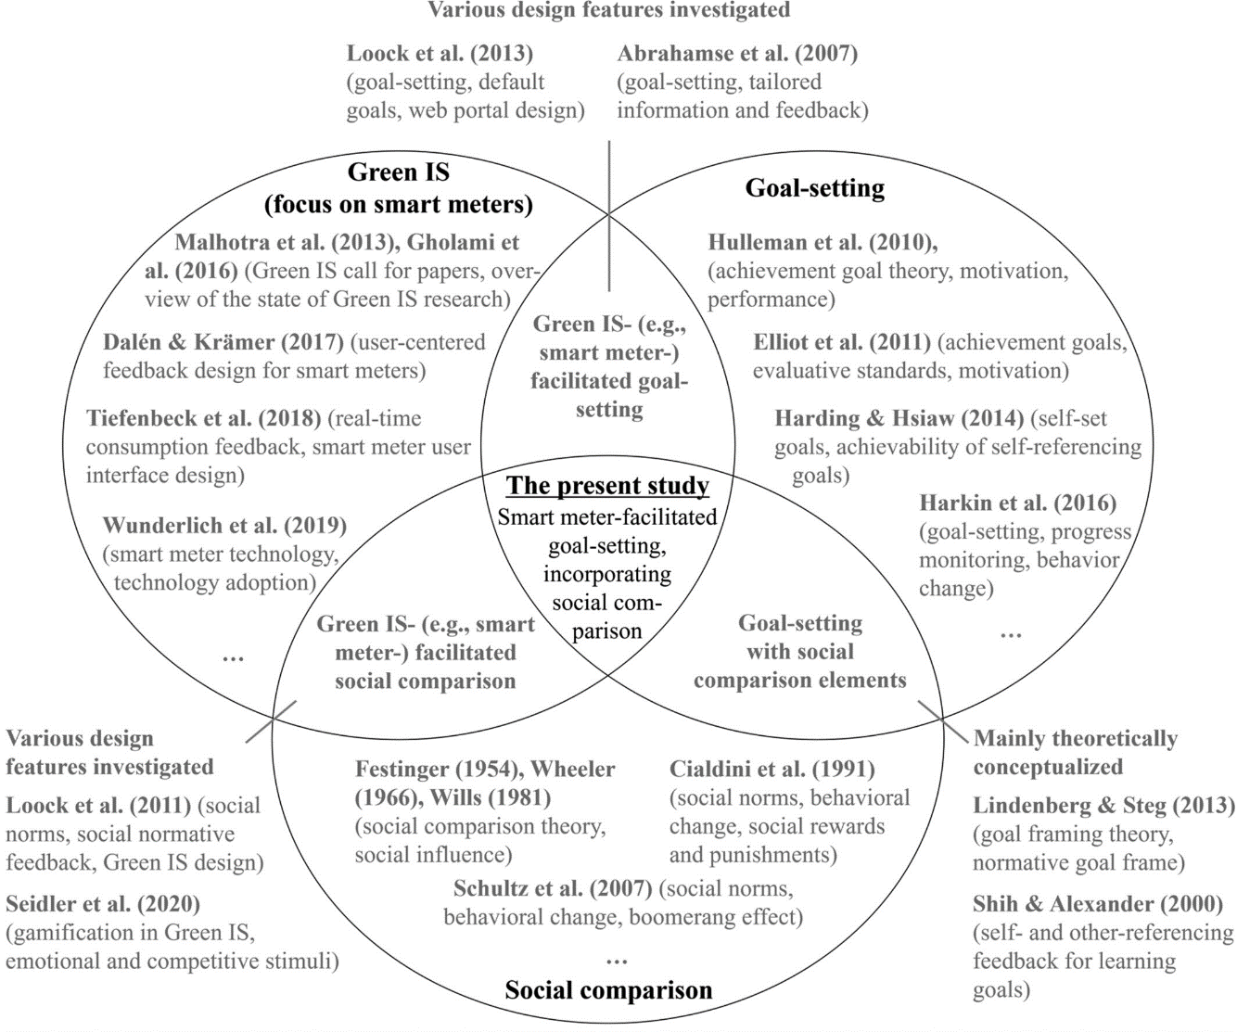
Figure 1. Illustrative Studies in the Green IS Literature Focusing on Smart Meters, Goal-Setting, and Social Comparison [source: Wendt et al. 2024]
Always reference and explain all tables and figures in the text. Check all figures for their quality during a test printing. If feasible: (Re)build graphs! No Screenshots!
  - Another Figure
This is exemplary text with cross reference (see Figure 2) to show another example of a figure. The caption is in “Figure/Table Caption” style and integrated, but below the figure.
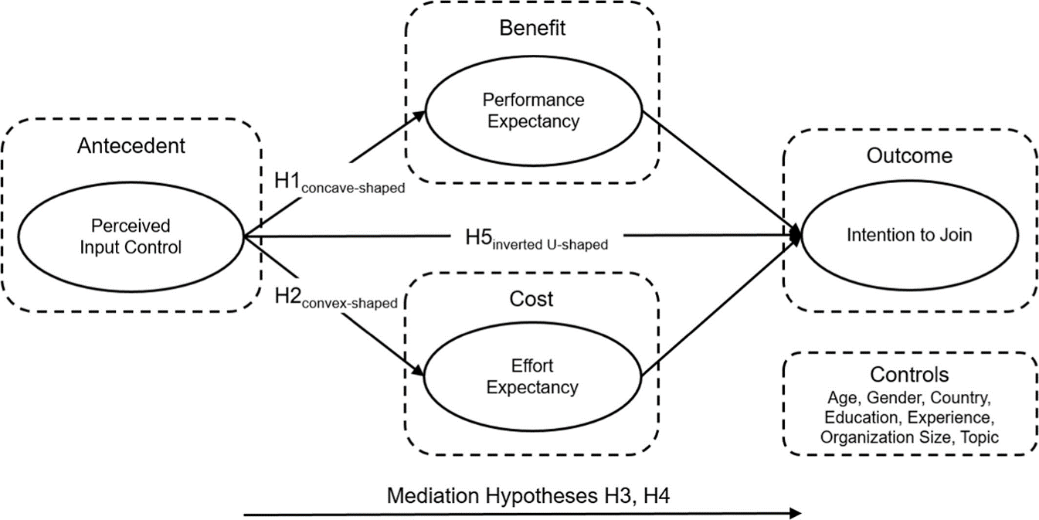
Figure 2. Research Model [source: Adam et al. 2022]

  - Table Style
This is exemplary text with cross reference (see Table 3) to show correct table style. The caption is in “Figure/Table Caption” style and integrated, but above the table.
Table 3. Descriptive Statistics of Demographics, Mediator, and Controls [source: Adam et al. 2021]
 | Mean | SD
Demographics
Age | 31.58 | 9.46
Gender (Females) | 54 %
Mediator
Social Presence (SP) | 3.23 | 1.54
Controls
Trusting Disposition (TD) | 4.98 | 1.17
Personal Innovativeness (PerInn) | 4.95 | 1.29
Product Involvement (ProInv) | 5.10 | 1.24
Conversational Agents Usage (CA Usage) | 2.25 | 1.51
Notes : N=153 ; SD= standard deviation

  - Another Table
This is exemplary text with cross reference (see Table 4) to show another example of a table. The caption is in “Figure/Table Caption” style and integrated, but below the figure.
Table 4. Experimental Design [source: Berger et al. 2021]
 |  | Human | Algorithmic
Unfamiliar |  | H-U | A-U
Familiar | Non-learning | H-F-N | A-F-N
 | Learning | H-F-L | A-F-L

References
Adam, M., Croitor, E., Werner, D., Benlian, A., & Wiener, M. (2023). Input control and its signalling effect for complementors' intention to join. Information Systems Journal, 33(3), 437-466. https://doi.org/10.1111/isj.12408
Adam, M., Wessel, M., & Benlian, A. (2021). AI-based chatbots in customer service and their effects on user compliance. Electronic Markets, 31(2), 427-445. https://doi.org/10.1007/s12525-020-00414-7
Berger, B., Adam, M., Rühr, A., & Benlian, A. (2021). Watch me improve—algorithm aversion and demonstrating the ability to learn. Business & Information Systems Engineering, 63(1), 55-68. https://doi.org/10.1007/s12599-020-00678-5
Wendt, C., Kosin, D., Adam, M., & Benlian, A. (2024). Sustainable energy consumption behaviour with smart meters: The role of relative performance and evaluative standards. Information Systems Journal. https://doi.org/10.1111/isj.12520
Appendix
A 1 Title
Here goes your text. This is exemplary text in “Text” style.
Do not include this or the following appendix in the final submission. Remove it from this document.
A 2 Thesis Submission
Upload your thesis and all data to Stud.IP:
- Your thesis in a “normal” (with name) version (PDF and Word) = 2 files
- Your thesis in an anonymous version (PDF and Word) (please remove both your name and the names of the chairholder and supervisor from this version) = 2 files
- All open data and document files (xls, doc, pdf), including: = 1 ZIP file
Export from Zotero resources as Zotero RDF with files
In case of qualitative research (e.g., interviews): overview of interview partners, transcripts, audio files, coding files
In case of quantitative research (e.g., surveys): questionnaire, prototype code, or data scraping code used for data collection, data collected, cleaning procedures, data analysis scripts and outputs
Use the following syntax when uploading your files:
YY_YYYYSS_XX_Titleofyourpaper_LastName.pdf (name version)
YY_YYYYSS_XX_Titleofyourpaper_anon.pdf (anonymous version)
YY_YYYYSS_XX_Titleofyourpaper_LastName_ESM.zip (Electronic supplementary material)
YY should be replaced by BT in case of Bachelor thesis, MT in case of Master thesis, BS in case of seminar thesis, MS in case of Master seminar,
YYYY should be replaced by the year you are starting your thesis, e.g., 2024
SS should stay in the case you start your thesis in the summer semester, or be replaced by WS if you start your thesis in the winter semester,
XX are the initials of your supervisor,
LastName is your last name (not included in anonymous version), Titleofyourpaper is an abbreviation of your paper (roughly max. 12 characters).
Example
BT_2024SS_MA_Mueller_Development of AI.pdf
BT_2024SS_MA_Development of AI_anonymous.pdf
For bachelor and master theses: Also follow the instructions of your examination office. Usually, you must upload the theses to FlexNow. For the examination office, only upload 1 PDF and necessary appendences (if any, no Zotero file or raw data upload to FlexNow necessary).

Chat GPT
- the use of ChatGPT must be completely transparent
- explicit marking of passages created with ChatGPT is required
- students should also explain in what way ChatGPT was used to create the examination paper
- you must attach the declaration of use to the end of your thesis
Declaration on the use of ChatGPT and comparable tools in the context of examinations
In this paper, I have used ChatGPT or another AI as follows.:
[ ] not at all
[ ] during brainstorming
[ ] when creating the outline
[ ] to write individual passages, altogether to the extent of ...% of the entire text
[ ] for the development of software source texts
[ ] for optimising or restructuring software source texts
[ ] for proofreading or optimising
[ ] further, namely: …
I hereby declare that I have stated all uses completely. Missing or incorrect information will be considered as an attempt to cheat.

