**Title**

**[Guidelines for writing theses and papers]**

XX weeks (length of time it took to complete) thesis as part of the

(state your full degree) degree at the University of Göttingen/ Seminar paper on…

|  |  |
| --- | --- |
| Submitted on: (Date of submission)  By: (First and last name)  From: (Place of birth) | Supervisor 1: John Doe  Supervisor 2: Foo Bar |

**Table of contents**

List of abbreviations iv

List of figures vi

List of tables vii

1 Structure of academic papers 1

1.1 Introduction 1

1.2 Basics (groundwork and definitions) 2

1.3 Main part 2

1.4 Conclusion 3

1.5 Appendix 3

1.6 References 3

1.7 Handout 3

2 Formal requirements 4

2.1 Headers and footnotes 4

2.2 Figures and tables 5

2.3 Equations 7

2.4 Subchapter, paragraphs and page margins 7

3 Citation and literature 8

3.1 MISQ-References Format 8

3.2 Types of citations 9

3.2.1 Literal citations 9

3.2.2 Analogous citations 10

3.3 Quality of the literature 10

3.4 Additional formatting opportunities 11

3.5 Citation software 11

4 Submission 12

5 References 13

Appendix 14

Certification 15

**Exemplary detail:**

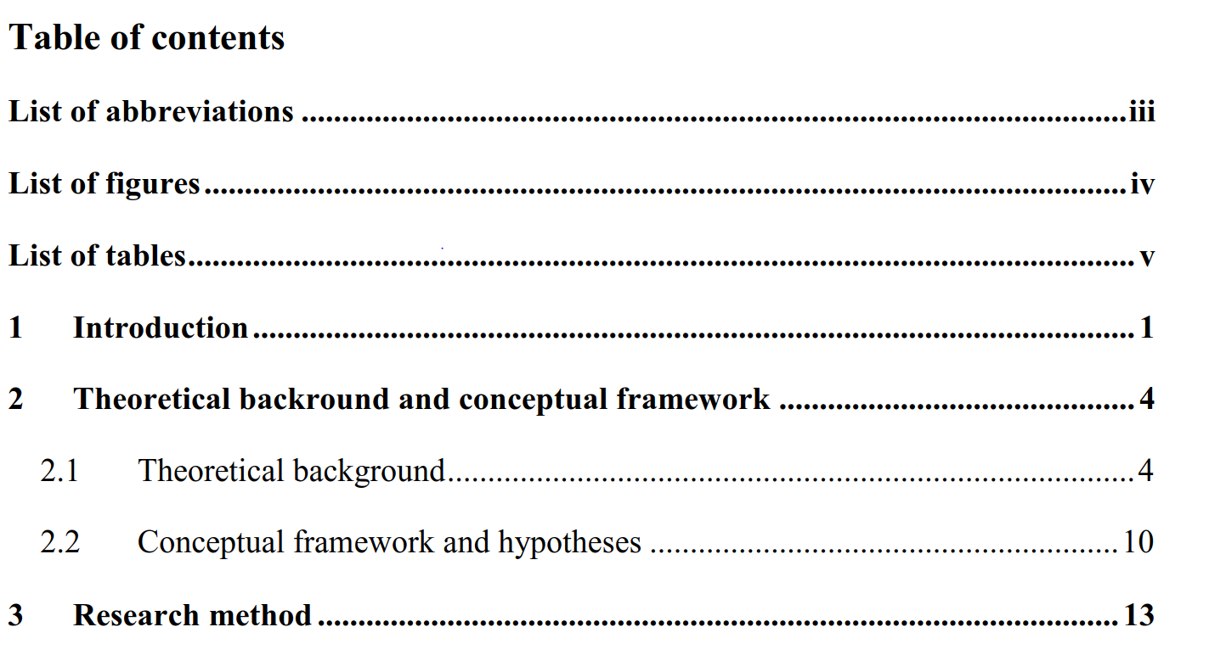

**Further information:**

* The composition of the text should be well-founded and structured. A new chapter should only be added if there are at least two subsections. The issue dealt with should not be processed in just one chapter.
* If different aspects are covered in one chapter or subsection, use paragraphs to structure the text.
* A good structure normally consists four to seven chapters (plus subsections/ subchapters).

# List of abbreviations

MISQ = Management of Information Systems

ISR = Information Systems Research

**Exemplary detail:**

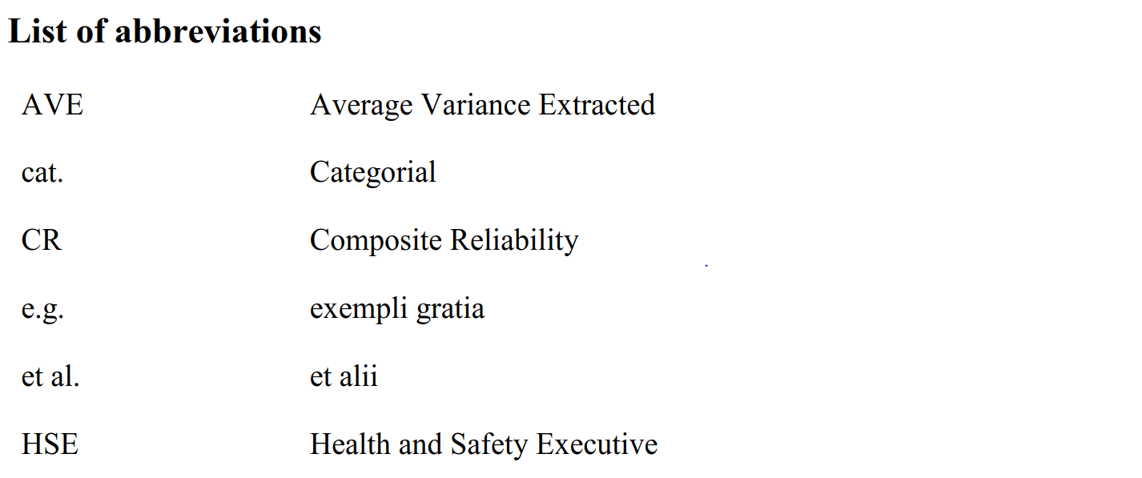

**Further information:**

The list of abbreviations should be placed after the list of contents and should use Roman Numbers.

It must include every abbreviation used in the paper (also in figures) and its meaning – sorted alphabetically – even if the meaning is already explained in the text. Permitted abbreviations, in accordance with “Duden” and other dictionaries, are those used for business and economic purposes, as well as those commonly used in journals, by institutions or by organisations.

For e.g.:

* IT = Information technology
* ITIL = IT Infrastructure Library
* CobiT = Control Objectives for Information and Related Technology

Abbreviations that are not commonly used are not permitted, as they disturb the reading flow (e.g.: AS for application system). Use abbreviations sparsely, some are common and should not be included in the list of abbreviations (e.g.: etc., viz., e.g., …).

# List of figures

Figure 1: IM [source: XX] 7

Figure 2: graph [own diagramm] 7

**Exemplary detail:**

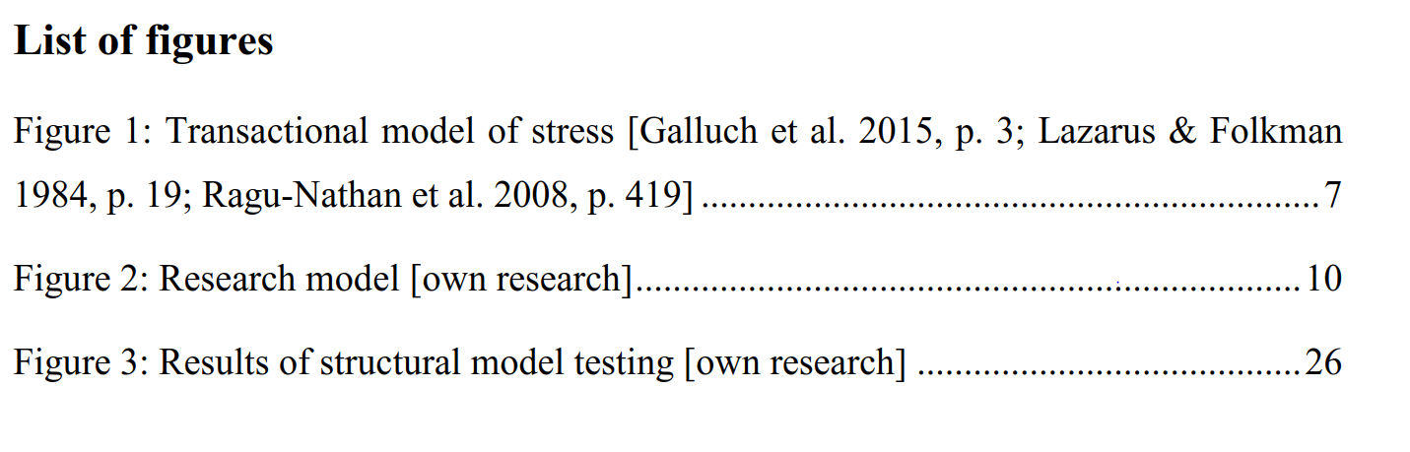

**Further information:**

* If there are more than four figures, statistics, tables etc. used in the text, a list of figures/tables should be included in the thesis/ paper. The figures/ tables/ statistics should be presented, named and numbered on a separate page after the list of abbreviations.
* All forms of display can be called figures and presented in one list of figures. A finer subdivision is sometimes not necessary.

# List of tables

Table 1: Table 1 [own research] 8

**Exemplary detail:**

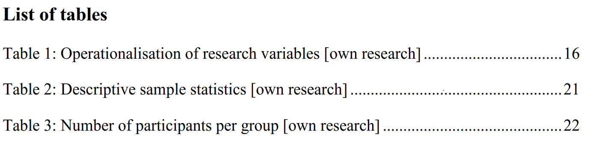

**Further information:**

# Structure of academic papers

A thesis or paper normally consists the following parts:

* Cover page
* Table of contents
* List of abbreviations (if necessary)
* List of figures (if necessary)
* List of symbols (if necessary)
* Text
* Appendix (if necessary)
* References
* Other sources (if necessary)
* Handout

**The following guidelines can be used as a template.**

The text of the thesis/ paper follows the list of figures/tables. It should be written in proper English orthography (British or American). Furthermore, other formal and content-related aspects need to be considered.

Every academic paper or thesis consists of the presentation of a problem, section of definitions, the actual solution or dealing with the problem and a summary of the main findings. A possible, typical structure could be:

1. Introduction
2. Groundwork/ literature review
3. Methods/ analysis
4. Findings/ evaluation
5. Conclusion

## Introduction

* In the first section you should always present the given issue of the paper/ thesis. Further comments regarding the relevance of the issue are also applicable.
* It should begin by dealing with some problems of the given issue. It is also handy to list the central issues of the thesis/ paper.
* Moreover, a short overview of the procedure, how and in which sequence the issues are going to be covered, etc., should be given.
* The following structure can be used for the introduction:

1. Introduction of the topic
2. Formulation of the issue
3. Definition of the subject (state subjects that belong to the topic, but are not covered)
4. Structure of the paper/thesis (reasons and motivation for the chosen structure)

## Basics (groundwork and definitions)

* In the second part, central terms and concepts need to be defined and classified.
* A short literature review is useful especially for practical papers/theses (e.g. according to Webster and Watson). The reader should be informed of the quantity and type of research papers published, related to the given issue.
* It is not a matter of looking for definitions from lexicons, but of using problem-oriented definitions.
* Often, some terms can be defined differently. So, a discussion of different approaches can be useful, before you choose a binding definition for the paper/thesis.

## Main part

* In the main part of the paper/thesis (which should be not named “main part” obviously), the actual issue or problem should be dealt with.
* In doing so, a theoretical model can be pictured, or theory-driven hypotheses can be developed, which can be examined empirically in a subsequent analysis.
* In this part, it is essential to not just use and collect textbook knowledge, but handle the issue in a reflective and goal-orientated manner.

## Conclusion

* The solution of the issues and problems dealt with should be represented briefly and concisely.
* In addition, you can give a further overview of issues that should be covered in future research.
* A critical reflection of the own work is always reasonable at this point.

## Appendix

You can put figures and diagrams in the appendix, which provide additional information. An appendix is not a necessary part of a paper/thesis, but rather an optional element, if further explanations are essential. This part should not be extended needlessly.

## References

* A bibliography must be attached to the work.
* The bibliography or list of references lists all publications cited in the paper/thesis, including those in tables or figures.
* Literature that was read but not cited does not belong in the list of references.

## Handout

* The handout (1-4 pages) should make it easier for seminar participants to understand the content of your presentation. Speak to your supervisor in order to find out, if a handout is necessary.
* A handout contains the topic, the editor, the structure, central definitions if necessary, tables, illustrations, theses and formulas.

# Formal requirements

In the following, the formal requirements for bachelor and master thesis as well as for seminar papers will be explained.

## Headers and footnotes

**Headers**

**Exemplary detail:**

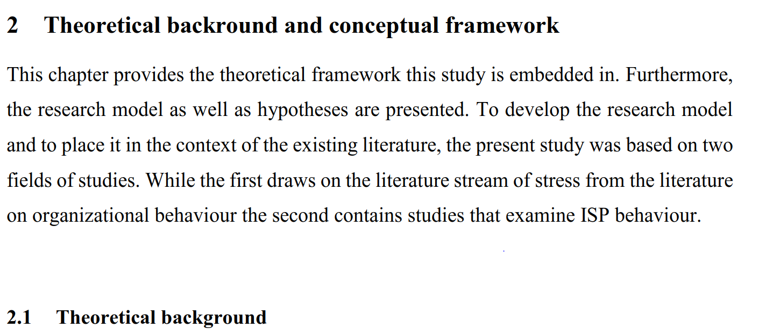

**Further information:**

* Avoid two or more subsequent headers without a text interposed.
* It is advisable to inform the reader about the structure of the following sections.

**Footnotes**

* Footnotes should be used carefully.
* If a reference is important, then it belongs in the text. If the reference is not necessary, you should consider whether the reference can be omitted.
* You can use footnotes, if certain sections need further explanations, which could disturb the reading flow.
* Footnotes should be written as normal sentences. They begin with a capital letter and end with a point.
* Concerning footnotes and punctuation: If a footnote relates to the whole sentence, it should be placed behind the punctuation mark, if the footnote relates to just one word, it should be placed behind the word it relates to and before the punctuation mark.

## Figures and tables

* Figures and tables do not only provide a visual relief.
* For figures and tables, you can summarise the pictured facts, illustrate certain matters or highlight statements.
* Figures and tables support your argumentation, but cannot replace your explanations. So further comments are necessary.
* Figures, tables etc. have to be numbered and labelled. The label can be, for example: Figure 1: Trade agreements between Canada and USA
* If figures or tables include necessary information, put them in the text. If they provide only additional information, they belong in the appendix.
* Figures and tables taken from other sources need to be cited correctly. The label has to include the source of the figure or table, i.e.: Figure 1: Trade Agreements USA/ GER [source: XX].
* If the figure or table was created personally, just write “own research”.
* If different sources were used for e.g., a table, and if it is not possible to cite it correctly, (you are required to allocate different sources to every number or fact in the table), do the following: at the beginning of the section, where this procedure takes action, cite every source used in the table and explain it in a footnote.

A figure looks like this:

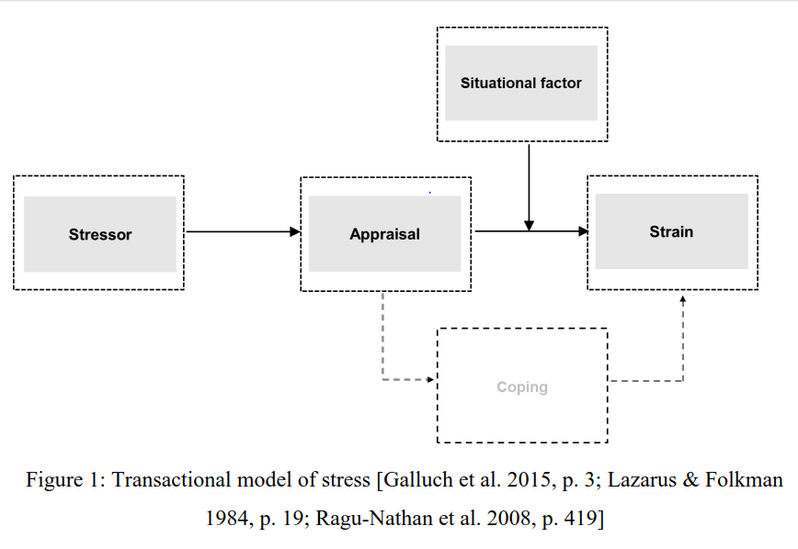

Figure 1: Transcational model of stress [Galluch et al. 2015, p. 3; Lazarus & Folkman 1984, p. 19; Ragu-Nathan et al. 2008, p. 419]

A table can be placed around the figure to create clear borders:

|  |
| --- |
|  |
| Figure 2: graph [own diagram] |

The presentation of a table can look like this:

|  |  |
| --- | --- |
| Header 1 | Header 2 |
| … | … |

Table 1: Table 1 [own research]

**Exemplary detail:**

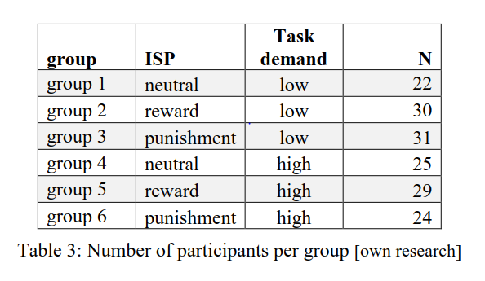

**Further information:**

Remember to explain or at least refer to every figure or table in the text. Labelling needs to be placed, as shown, below the figure/table.

## Equations

|  |  |
| --- | --- |
| $$\left[\frac{\left(Z-E\left(Z\right)\right)}{V^{-1}\left(Z-E\left(Z\right)\right)}\right]=\frac{2\left(\frac{∂y}{∂x}\right)}{V^{-1}(Z-E\left(Z\right))}$$ | (1) |

This is how formulas or equations should be presented, like equation (1) above. Formula symbols and the meaning of abbreviations need to be explained. Own formulas need to be defined. A list of formula symbols can be necessary (after the list of tables).

## Subchapter, paragraphs and page margins

**Sublevels**

Do not use more than four subchapters (sublevels). Create only a new sub level if it is necessary.

**Paragraphs and page margins**

* Use a line spacing of 1.5.
* Paragraphs should be placed content-related and reasonable.
* The page margins should 2,5cm for all margins.
* The text should be full justified.

# Citation and literature

Basically, every time external information or a foreign idea is taken as a source for an academic paper, whether it is used literally or analogous, it has to be cited correctly.

An essential requirement for academic working is the correct and complete citation of foreign ideas.

**Correct and complete citation means, that every foreign idea has to be marked, in the text and in the references. A consistent reference format and citation style are especially important. There must be no differences in the notation and sources cited, in the references and in the text. Use the MISQ-References Format (<http://misq.org/manuscript-guidelines>).**

## MISQ-References Format

Use the MISQ-Style for your paper or thesis, as explained in the following.

* **Sequence:** Entries should be ordered alphabetically (in text and Reference section) according to authors’ or editors’ last names, or the title of the work for items with no author or editor listed.
* **References in text (cf. Chapter 3.2):** These must be included in the Reference section and vice versa. References in text should be of the format (Jones et al. 1995; Smith 1996).

An example for a correct citation in the text:

*Others have argued that because services are performed for particular clients in a particular circumstance, service innovation should be examined as emergent, interactive, and dynamic, as well as knowledge and information intensive as communication flows between providers and customers (Miles 2008, p. 117).*

**Different types of references should include the following in the list of references (bibliography):**

* **References to items in periodicals:** Author, year, title, journal, volume, number, month, pages. For authors, last names are given first, even for multiple instances.

**Exemplary detail:**

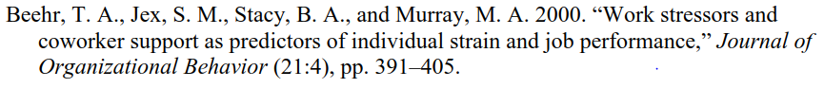

* **References to reports or proceedings: Author’s** name and title of report (same style as above), report number, source, editor and/or publisher as appropriate, city and state/country of publisher OR full name of conference as appropriate, including date and pages.

**Exemplary detail:**

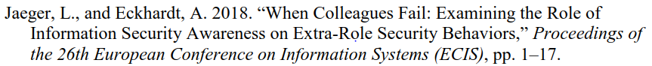

* **References to books:** Author’s name (same style as above), year, title, city, state/country, publisher, page, or chapter.

**Exemplary detail:**

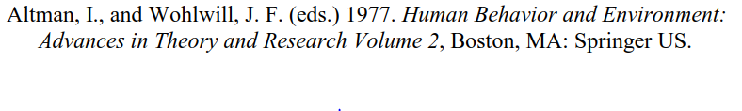

* **References to internet pages:** Author’s name, title, medium, date, edition, page etc. (if possible), Link with date of call.

**Exemplary detail:**



**Use of et al.:** Authors may not use “et al.” in the list of References. The names of all authors and editors must be listed. If you are using End Notes, please check your references to ensure that the settings are correct and that all authors are listed in the references.

**An example of a correct bibliography (list of references) can be found at the end of this template.**

Moreover, it is advisable to read an MISQ-Article if there are further open questions, and to check how to cite correctly and how to create a bibliography.

## Types of citations

Concerning the type of citation, one can distinguish between literal and analogous citations.

### Literal citations

Text passages adopted literally (sentences, clause, individual words) have to be cited with quotations marks. If you cite literally, alterations of the text passages are not allowed. The omission of one word has to be mark with two dots, the omission of two or more words has to be marked with three dots. Long literal citations should be avoided, it is better to write a corresponding summary instead. It is necessary to cite literally in the following four cases:

* It is not possible to explain the relevant content in a better or shorter manner.
* It is a concept formation.
* If textual criticism or critical comments have to be formulated, viz. if you have to interpret or criticise the author.
* Literature in other languages than English as addition to the analogous reproduction, so that the reader can check if the author translated correctly.

If something is added within the citation, it must be marked correctly. The added passage needs to presented in brackets and initials of the author have to be added. For example: “The function of … (the network) … can be summarised …”.

### Analogous citations

It is important to mind the complete citation of used references for analogous citations as well.

If nothing else is indicated, the citation refers to the marked sentence. If various sentences are cited analogously, you have to indicate it in a proper manner (e.g. through indentation or a reference of the extent of the analogous citation). If a notation is missing, it will be assumed that only the marked sentence is cited.

If you write a text passage based on multiple pages of an external source, it has to be marked properly by a correct citation, i.e. (Jones 2012, pp. 12-16).

A citation should always come from a primary source and not from a secondary source. If such a citation is necessary (because e.g. a primary source is not locatable), one has to use a footnote that mentions the primary source, then the note “cited from [secondary source]”.

Wrong or missing indication of used sources leads, in general, to a rejection of the thesis/ paper.

## Quality of the literature

References and literature sources are often of different quality. Practice-orientated sources enrich academic papers, but should be not used solely. It is expected, that English (or German) sources will be sighted and used exclusively. Wikipedia and comparable lexicons are not appropriate!

## Additional formatting opportunities

For books, periodicals and reports it is possible to format the title, the name of the periodical or report in italic in order to gain a better readability.

## Citation software

The use of citation- and reference management programs liken Citavi or Mendeley is recommend.

The University of Göttingen offers a campus licence for Citavi for students and employees of the university. Students and employees are able to download the full version for free. Mendeley is in general, free of cost.

# Submission

* You have to submit a PDF file via E-mail to your supervisor. Furthermore, a printed copy may be required by your supervisory, and this should be submitted to your supervisor or secretary. Coordinate with your supervisor!
* Original Files (Word, etc.) have to be submitted on request.
* Sources must be kept up till grading.
* Bachelor or master theses must be handed in at the examination office, seminar papers at the secretary’s office.
* Theses need to be bound (adhesive bind)

# References

Ackoff, R. L. 1961. “Management Misinformation Systems,” *Management Science* (14:4), S. 147-156.

Bonini, C. P. 1963. *Simulation of Information and Decision Systems in the Firm, Englewood Cliffs*, NJ: Prentice-Hall.

Chenhall, R. H., and Romano, C. A. 1989. “Formal Planning and Control Presence and Impact on the Growth of Small Manufacturing Firms,” in *Job Generation by the Small Business Sector in Australia*, W. C. Dunlop and A. J. Williams (eds.), Newcastle: Institute of Industrial Economics, S. 71-89.

Mair, S. *Staatsversagen und Staatszerfall, in: Informationen zur Politischen Bildung* (2009), Nr. 303, S. 8-10. <http://www.bpb.de/files/ES3BIB.pdf>. Accessed: 01.10.2009.

# Appendix

**As described in chapter 1.5, you can add appendices here. Use an alphabetic numeration.**

# Certification

"I hereby declare that I wrote this thesis paper independently, without assistance from external parties, and without use of other resources than those indicated. All information taken from other publications or sources in text or in meaning are duly acknowledged in the text. The written and electronic forms of the thesis paper are the same. I give my consent to have this thesis checked by plagiarism software."

|  |  |  |
| --- | --- | --- |
|  |  |  |
| Place, Date |  | Signature |