Title of this Abstract
(If necessary subtitle or delete row)
First author’s name

Institution
University / Company

(If necessary repeat for other institutions. For multiple institutions use superscript numbers after the author's name and in front of the institution.)

Abstract (required)
In this document we describe the formatting requirements for the Proceedings of the ResEff Conference. Please review this document carefully. You can use this document as a template and copy/paste your paper content here (this might be the best or easiest way). Please be sure to adhere to the formatting requirements as this will be your camera-ready version, and a PDF format will be generated directly from your submitted final Word version. Please note several limitations on length: (1) your abstract should be no more than 2 pages, as the abstract will also be used for the conference program, (2) your entire paper should be no more than twelve pages, including all materials and sections such as figures, tables, and references.

Keywords (required)
The paper must have at least one keyword. For more than one keyword, please use a comma as a separator.

Introduction
The accepted papers and the panel statements of the conference are published in the Conference Book. We wish to give the conference book a consistent, high-quality appearance. We therefore ask that authors follow some basic guidelines. In essence, you should format your paper exactly like this document. The easiest way to use this template is to download it from the conference webpage and replace the content with your own material.

Formatting and Structure
To format the title of an article, please use 16-point bold Garamond font style. For the subtitle if necessary please use Garamond 14-point bold Garamond font style. The author’s names and the Institutions, please format as 13-point italic Garamond font style.

Headings
The titles of the highest order should be formatted with the template 13-point bold Garamond, according to the following hierarchy level with 12-point bold Garamond. The headings of the abstract and keywords should be formatted with the template 13-point bold Garamond.

Normal or Body Text
Please use the 11-point Garamond for the standard text. After headlines, pictures, enumerations, or inserts, a text is not indented. All paragraphs in the text are set without teaching line and instead receive the indentation.
Here you can see one visual example of the paragraph indentation in the text.

Header
Use Words “side view”. You can click on the header twice and edit the text it contains. On a straight page (2, 4, 6, ...) you can edit the author’s name (you might want to use an abbreviated version) and on an odd page (1, 3, 5, 7, ...) the name of tracks. The adjustment affects all the pages of your article and need not be repeated. Please leave the page numbers alone.

Tables and Figures
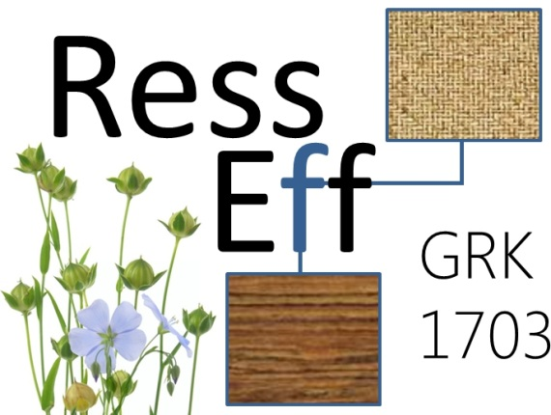
Place figures and tables close to the relevant text (or where they are referenced in the text).
Figure 1: Example figure

Captions should be in 10-point Garamond font style. They should be numbered (e.g., “Table 1” or “Figure 2”) and placed beneath the figure. For tables we accept above the table. Please note that the words “Figure” and “Table” should be spelled out (e.g., “Figure” rather than “Fig.”) wherever they occur. You are advised to refrain from using colors to deliver important information in your figures. Figure resolution should be at least 300 dpi.
Table 1: Example table
 | Treatment 1 | Treatment 2
Setting 1 | A | B
Setting 2 | C | D
Setting 3 | E | F

Equations
Equations should be placed on a separate line, numbered and centered. An extra line space should be added above and below the equation.
The numbers accorded to equations must appear in consecutive order inside each section or within the contribution, with number enclosed in brackets and set on the right margin, starting with the number 1.
The use of a table with two columns is advisable.
Example:

a = b + c | (1)

Reference Text and Citations
References and citations should follow the Harvard (Author, date) System Convention (see the References section). As example you may consider the citation (Smith, 1998) or (Dennis & Meredith, 2000) or (Li et al., 2006). Besides that, all references should be cited in the text. Citations should follow the section text format.

Conclusions
We hope you find the information in this template useful in the preparation of your submission.

References
Brown, J., 2005. Evaluating surveys of transparent governance. In: UNDESA (United Nations Department of Economic and Social Affairs), 6th Global forum on reinventing government: towards participatory and transparent governance. Seoul, Republic of Korea 24-27 May 2005. New York: United Nations.
Dennis, D. & Meredith, J., 2000. An Empirical Analysis of Process Industry Tranformation Systems. Management Science, 46(8), pp. 1085-1099.
Environmental Paper Network, 2012. The State of the Paper Industry 2011. Steps Toward an Environmental Vision. [Online] Available at: http://environmentalpaper.org/documents/state-of-the-paper-industry-2011-full.pdf [Accessed 20 Februar 2013].
Foster, L. D. L. & Lees, J. A., 2000. Tracers in Geomorphology: Theory and Applications in Tracing Fine Particulate Sediments. In: J. D. L. Foster, ed. Tracers in Geomorphology. Chichester, New York, Weinheim, Brisbane, Singapore, Toronto: John Wiley & Sonn Ltd., pp. 3-20.
Li, S., Visich, J. K., Khumawala, B. M. & Zhang, C., 2006. Radio Frequency Identificaiton Technology: Applicaitons, Technical Challenges and Strategies. Sensor Review, 23(3), pp. 193-203.
Smith, J., 1998. The book, The publishing company. London, 2nd edition.

