Titel of the abstract maximal two lines (Font type: Arial, Font size: 14 pts)

Author A.¹*, Author B.², Author C.²

¹ Institute address of Author A
² Institute address of Author B
³ Institute address of Author C
* email: e-mail address of presenting author

Text … (Font type: Arial, Font size: 11 pt) Minimum 300 words; maximal 2 pages including figures. Text text text text text text text text text text text text text text text text text text text text text text text text text text text text text text text text text text text text text text text text text text text text text text text text text text text text text text text text text text text text text text text text text text text text text text text text text text text text text text text text text text text text text text text text text text text text text text text text text text text text text text text …

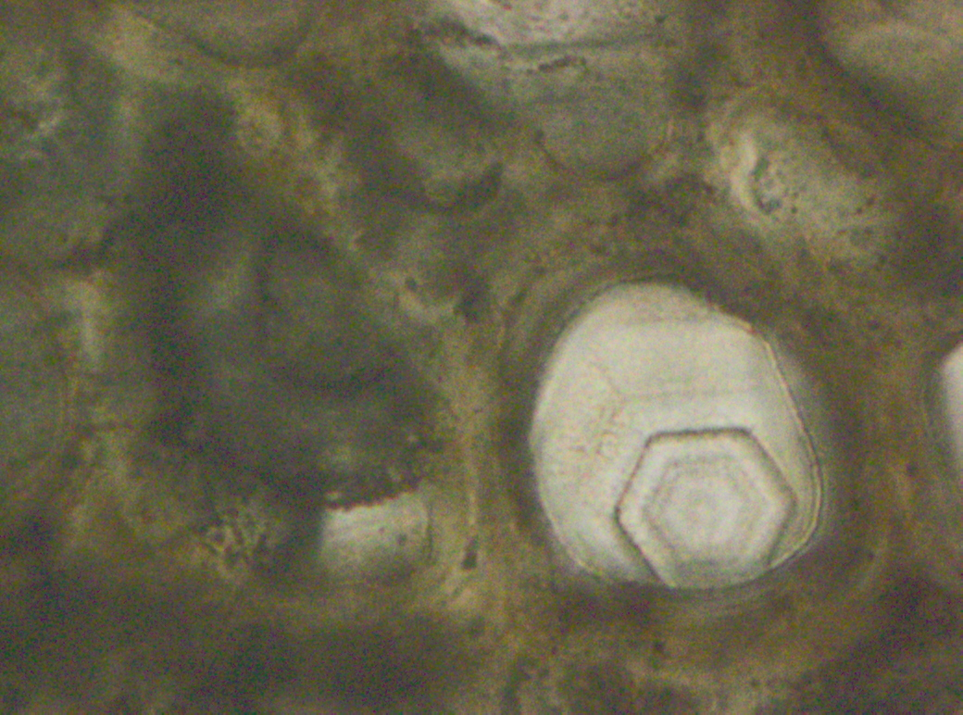

Fig. 1: Idiomorphic quartz crystal in fossilized wood (Font type Arial italics pt 10).

Text … text text text text text text text text text text text text text text text text text text text text text text text text text text text text text text text text text text text text text text text text text.
References:
Author X., Author Y., Author, Z. (2010) Journal name with abbreviation, Vol X, 12-13.

