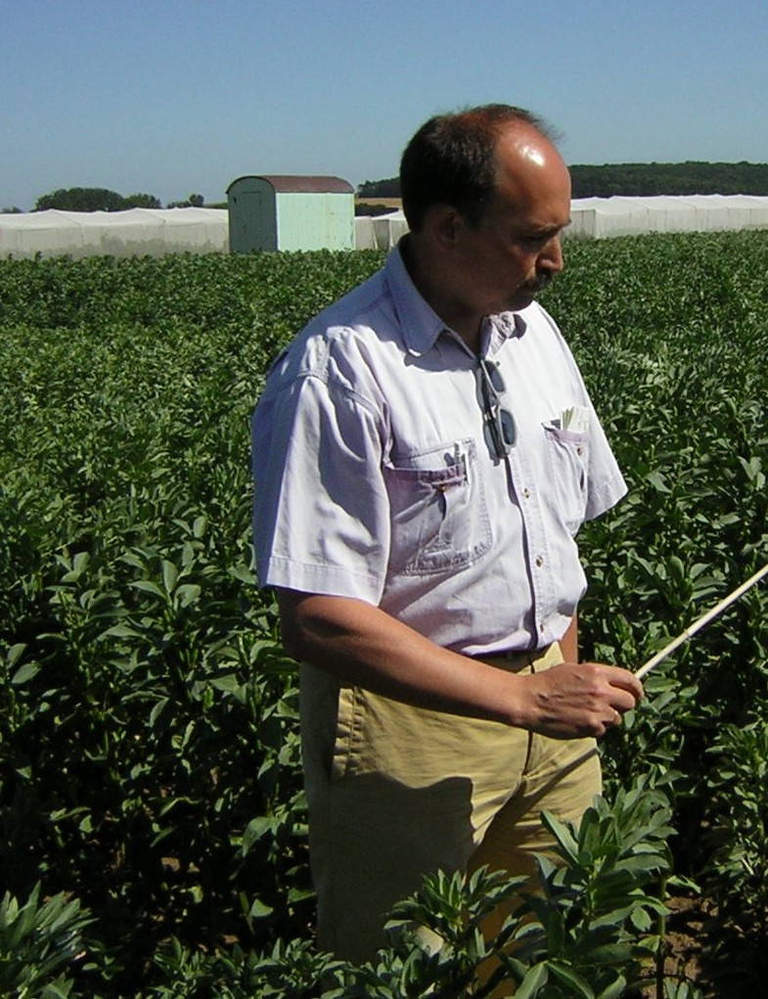
Dr. Wolfgang Link
Georg-August-University
Department of Crop Sciences (DNPW)

University of Hohenheim, Stuttgart
1979 – 1984 | MSc in Agric. Biology
1984 – 1988 | PhD in Plant Breeding
Thesis: “Autofertiliy and degree of cross-fertilization as crucial traits in breeding Vicia faba L. minor (small-seeded faba bean)”
1986 (Vienna) | Kurt-von-Rümker-Award
1988 – 1994 | Assistant Professor (C1)  Supervisors: Peter Ruckenbauer & Albrecht Melchinger Graduation to Dr. habil.

Thesis: “Breeding method in case of partial allogamy”
1994 - 1995 | Research Associate at the State Plant  Breeding Institute

Georg-August-University, Göttingen
1995 - today | Venia legendi for “Plant Breeding”  Lecturer and researcher in the  Plant Breeding Unit (Head: Heiko Becker)
1999 | Nomination “apl. Professor”
Von Siebold 8, D – 37075 Göttingen
wlink@gwdg.de
http://www.uni-goettingen.de/de/sh/48273.html

