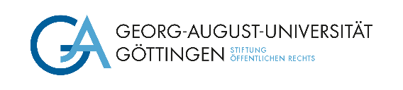

The Department at the Georg-August-Universität Göttingen is looking to fill the position of a

**Research Assistant (f/m/d)**

at the       with      . Regular working hours will be (currently       hours per week) with a limited contract of       year(s) / to      . This position should be filled by Date. Salary: Pay grade 13 TV-L.

**Your duties**

• You will teach courses as defined in Section 31 of the Higher Education Act of Lower Saxony (NHG) and Administer examinations

• Work on the research area of RESEARCH AREA

**Your profile**

• You hold a highly qualified PhD in SUBJECT,

• have a research focus on RESEARCH FOCUS,

• are willing to collaborate in setting up a research network on SUBJECT,

• are proficient in LANGUAGE,

• have teaching experience and publishing results.

This post is designed to serve in fostering young researchers and scientists and give the successful applicant the opportunity to pursue a post-doctoral degree. The position is also suitable for half-time work.

The University of Göttingen is an equal opportunities employer and places particular emphasis on fostering career opportunities for women. Qualified women are therefore strongly encouraged to apply in fields in which they are underrepresented. The university has committed itself to being a family-friendly institution and supports their employees in balancing work and family life.The mission of the University is to employ a greater number of severely disabled persons. Applications from severely disabled persons with equivalent qualifications will be given preference.

Please send your application with the usual documents (also in electronic form) by Date/within **three weeks after publication of this advertisement** to **Georg-August-Universität Göttingen**, **Department,**

**StreetHouseNr,** **PLZ Göttingen, e-mail:** **.**



If you have any questions, please contact Ms./Mr. Name, phone:       , e-mail:      .

**Please note:**

With submission of your application, you accept the processing of your applicant data in terms of data-protection law. Further information on the legal basis and data usage is provided in the Hinweisblatt zur Datenschutzgrundverordnung (DSGVO) <https://www.uni-goettingen.de/hinweisdsgvo>